Relationships and Sex Education Policy
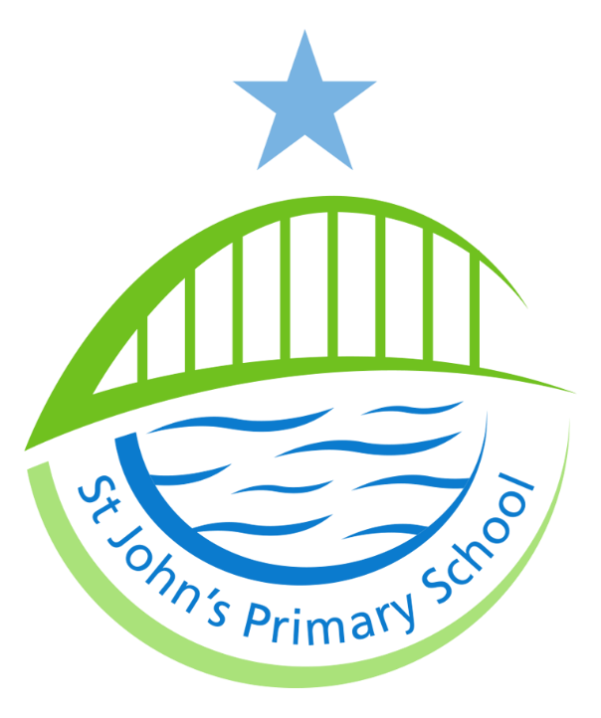

October 2020
Reviewed:

1. Aims
The aims of relationships and sex education (RSE) at our school are to:
- Enable children to understand how to keep themselves and others safe
- Develop the personal skills needed by pupils for them to establish and maintain relationships, to recognise what a healthy relationship looks like, to form healthy relationships, ensuring respect and dignity for themselves and others
- Explore how to live well together, including behaving well towards others, disagreeing well, forgiving and repairing broken relationships
- Develop the skills to express their own views and make their own informed decisions, providing a framework in which sensitive discussions can take place
- Help pupils develop feelings of self-worth, self-respect, confidence and empathy, to cherish themselves and others as unique and wonderfully made
- Create a positive culture around issues of sexuality and relationships
- Teach pupils the correct vocabulary to describe themselves and their bodies
- Prepare pupils for puberty, by giving them an understanding of the importance of health and hygiene
- Enable children to make responsible and informed decisions about their health and well-being.
2. Statutory requirements
As a Primary School we are required to follow the National Curriculum, which would include the elements of sex education contained in the science curriculum.
3. Policy development
This policy has been developed in consultation with staff, pupils and parents. The consultation and policy development process involved the following steps:
- Review –The PSHE lead pulled together all relevant information including relevant national and local guidance
- Staff consultation – all school staff were given the opportunity to look at the policy and make recommendations
- Governor consultation- this included wider reading around RSE, the equality act and the national curriculum
- Parent/stakeholder consultation – The policy was made available to parents on the website for two weeks and they were invited to discuss any points
- Ratification – once amendments were made, the policy was shared with governors and ratified
4. Definition
RSE is about the emotional, social and cultural development of pupils, and involves learning about relationships, sexual health, sexuality, healthy lifestyles, diversity and personal identity. RSE involves a combination of sharing information, and exploring issues and values.
RSE is not about the promotion of sexual activity.

5. Curriculum
Our curriculum is set out in Appendix 1. This will be reviewed and adapted as and when necessary. We have developed the curriculum in consultation with parents, pupils and staff, taking into account the age, needs and feelings of pupils. Our curriculum content is based on resources provided by the PSHE association. Teachers will use the objectives and always take into account the needs and feelings of our pupils.
If pupils ask questions outside the scope of this policy, teachers will respond in an appropriate manner so they are fully informed and don’t seek answers online.
Primary sex education will focus on:
- Preparing boys and girls for the changes that adolescence brings
- How a baby is conceived and born
For more information about our curriculum, see our curriculum map in Appendix 1.
6. Delivery of RSE
At St John’s Primary School RSE is delivered within the personal, social, health and economic (PSHE) education curriculum. It also compliments content covered in Science, Computing and PE, and other aspects are included in religious education (RE).
Appendix 1 shows how our PSHE curriculum covers all the strands of the statutory guidance.
Relationships education focuses on teaching the fundamental building blocks and characteristics of positive relationships including:
- Families and people who care for me
- Caring friendships
- Respectful relationships
- Online relationships
- Being safe
These areas of learning are taught within the context of family life taking care to ensure that there is no stigmatisation of children based on their home circumstances (families can include single parent families, LGBT parents, families headed by grandparents, adoptive parents, foster parents/carers amongst other structures) along with reflecting sensitively that some children may have a different structure of support around them (for example: looked after children or young carers).
7. Inclusion
Equality
St John’s Primary School is an inclusive school where we place a strong focus on the wellbeing and progress of every child and where all members of our community are of equal worth.
Schools have a legal duty to promote equality (Equality Act, 2010) and to combat bullying (Education Act, 2006) (which includes homophobic, sexist, sexual and transphobic bullying) and Section 4.2 of the national curriculum (2014) states “Teachers should take account of their duties under equal opportunities legislation that covers race, disability, sex, religion or belief, sexual orientation, pregnancy and maternity, and gender reassignment.”
RSE has clear links with other school policies aimed at promoting pupils’ spiritual, moral, social and cultural development, including the:
- Anti-Bullying Policy
- Behaviour Policy
- Confidentiality Policy
- Equality and objectives Policy
- Health and Safety Policy
- Computing Policy and E Safety Policy
- RE Policy
- Safeguarding/Child Protection Policy
- Special Educational Needs Policy
SEND
At St John’s Primary School Relationships and Health Education is accessible for all pupils. We provide high quality teaching that is differentiated and personalised to ensure accessibility.
8. Roles and responsibilities
The Governing body
The governing body has delegated the approval of this policy to The Curriculum and Performance Committee and it will hold the Headteacher to account for the implementation of this policy.
The Headteacher
The Headteacher is responsible for ensuring that RSE is taught consistently across the school, and for discussing any concerns or issues parents may have.
The Curriculum Leader
The Curriculum Leader will:
- develop a differentiated curriculum;
- work closely with subject coordinators in Science, Computing R.E and P.E. to ensure Relationships Education, Sex Education and Health Education do not duplicate content covered in the National Curriculum;
- work with external organisations in order to enhance delivery of these subjects by introducing specialist knowledge and different ways of engaging with pupils;
- ensure that the teaching delivered by a specialist teacher fits with the planned programme;
- provide strategic leadership and direction;
- provide a curriculum that provides pupils with the essential knowledge they need to be educated citizens in democratic Britain;
- promote an awareness of and respect for a diversity of cultures, values, beliefs and abilities;
- ensure appropriate coverage of the curriculum;
- provide support and advice;
- monitor pupil progress in this area;
- ensure sufficient and up to date resources are in place
- provide guidance and support to all staff;
- provide training for all staff on induction and when the need arises regarding;
- make effective use of relevant research and information to improve this policy;
- keep up to date with new developments and resources;
- undertake risk assessments when required;
- review and monitor the implementation of the policy and curriculum;
- annually report to the Governing Body on the success and development of this policy
Staff
Staff are responsible for:
- Delivering RSE in a sensitive way
- Modelling positive attitudes to RSE
- Monitoring progress
- Responding to the needs of individual pupils
Staff do not have the right to opt out of teaching RSE. Staff who have concerns about teaching RSE are encouraged to discuss this with the Headteacher.
Pupils
Pupils are expected to engage fully in RSE and, when discussing issues related to RSE, treat others with respect and sensitivity.
9. Parents’ right to withdraw
Parents do not have the right to withdraw their children from relationships education. Parents have the right to withdraw their children from the non-statutory/non-science components of sex education within RSE. Requests for withdrawal should be put in writing and addressed to the Headteacher. Alternative work will be given to pupils who are withdrawn from sex education.
10. Training
Staff are trained on the delivery of RSE as part of their induction and it is included in our continuing professional development calendar. The Headteacher will also invite visitors from outside the school, such as school nurses or sexual health professionals, to provide support and training to staff teaching RSE.

