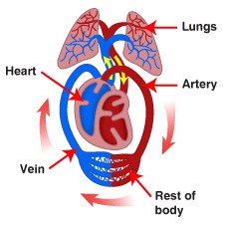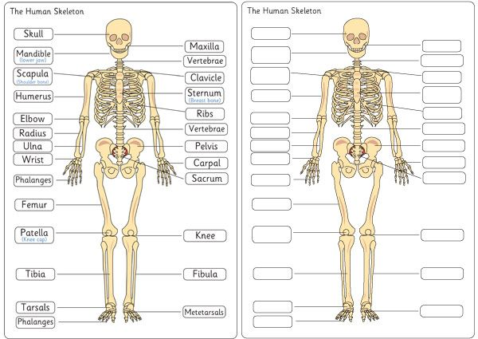

**Key Vocabulary**

**Arteries – Muscular-walled tubes that transport blood from the heart to other parts of the body**

**Blood – Red liquid that circulates in arteries and veins, carrying oxygen to and carbon dioxide from tissues of the body**

**Blood vessel – A tubular structure carrying blood through the tissues and organs**

**Bones – Hard whitish tissue making up the skeleton in humans and other vertebrates**

**Circulatory system – The system that circulates blood through the body, including the heart, blood vessels and blood**

**Heart – A hollow muscular organ that pumps the blood through the circulatory system**

**Lungs – Pair of organs situated within the ribcage where oxygen can pass into the blood and carbon dioxide be removed**

**Muscles – A band or bundle of fibrous tissues that have the ability to contract, producing movement in or maintaining positions of parts of the body**

**Nutrients – A substance that provides nourishment essential for the maintenance of life and for growth**

**Organs – Part of an organism that is typically self-contained and has a specific vital function (e.g. the heart and lungs)**

**Veins – Tubes forming part of the blood circulation system of the body, carrying mainly oxygen-depleted blood towards the heart**

**Vitamins – Organic compounds essential for normal growth and nutrition**

**Animals including humans**

