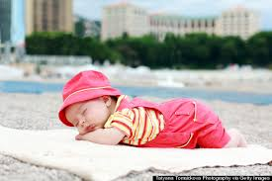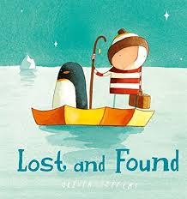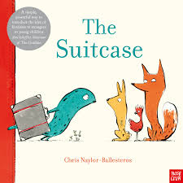

**Responsible Team:**  - The Tracking Company

**Client:** Initially mum of the abandoned baby

**Commission:** to help reunite mum and baby.to care for a young baby, show compassion, care and understanding to the plight of refugees

**As responsible members of a team can we…?**

Understand how we should behave

Share opinions on things that matter to them and explain their views;

Recognise, name and deal with their feelings in a positive way;

Think about themselves, learn from their experiences and recognise what they are good at;

Take part in discussions with one other person and the whole class;

**As STEM thinkers and problem solvers, can we…?**

|  |
| --- |
| asking simple questions and recognising that they can be answered in different ways  observing closely, using simple equipment  make suggestions on how to care for baby, design a cradle, keep a baby and a bottle warm |

**As Geographers can we…?**

Discuss the different seasons

Use geographical language including: beach, cliff coast, forest, hill, mountain, sea, ocean

city, town, village, factory, farm, house, office, port, harbour and shop

**Big Questions:**

* Should we care for people from other countries?
* Why is there an increasing number of families that need care and support from

outside the family?

* How can we learn to live with people that could be tricky to get along with?
* Where do we get food from (if not from a shop?)

**Year 1 – The Tracking Company**

**As Historians can we…?**

understand that the world changes, changes

name famous people who have had an impact on our lives.

**As writers and communicators can we…?**

Enjoy a range of texts

Know that information can be retrieved from books and computers

compose a sentence orally before writing it write notes and cards sequence sentences to form short narratives re-reading what they have written to check that it makes sense discuss what they have written with the teacher or other pupils

* read aloud their writing clearly enough to be heard by their peers and the teacher

**As ‘artists and makers’ can we…?**

Respond to art and artists,

Respond with different moods, and colours.

**Hooks for Learning:**

**Texts:** Lost and Found – Oliver Jeffers. The Suitcase - Chris Naylor

**Trips:** Healthy eating

**Artefacts:** Baby on beach, pebbles,baby clothes and artefacts. Leanne and Rahim