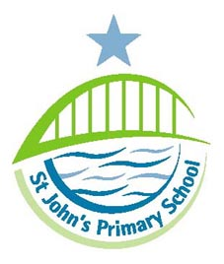
St John’s Primary School

Teindland Close

Benwell

Newcastle

NE4 8HE

Email: admin@stjohns.newcastle.sch.uk

2 x Lunchtime Supervisory Assistant

£24,988 per annum, pro rata (Actual £3,588 per annum, subject to Newcastle Living Wage and pending pay award)

6.25 hours per week, plus 3 training days, term time only. Fixed term for one year initially.

The Governors are seeking to appoint two lunchtime Supervisory Assistants who share our vision for quality education to join our team of committed staff in this successful school.

Required to start in September, to work under the co-ordination of the Mid-day Supervisor ensuring the safety and welfare of pupils during the mid-day break. The successful candidates will be committed to promoting the Food Standards for Schools and able to lead purposeful play for pupils.

St John’s Primary School is strongly committed to safeguarding and promoting the welfare of children and young people. The successful candidate shall be required to undertake an enhanced DBS disclosure and barred list check plus a range of other recruitment checks.

For an informal discussion about the post, please contact Marie Bartley (School Business Manager) on (0191) 273 5293 (option 4)

An application pack is available to download from the school website www.stjohns.newcastle.sch.uk/site. Applications may be returned via email to marie.bartley@stjohns.newcastle.sch.uk

Closing date for applications is Friday 25th July with interviews taking place on Wednesday 30th or Thursday 31st July.

