Knowledge Organiser: Rivers - Rivers are natural streams of water. They are formed by the movement of water from high ground to lower ground and then usually to the sea.
What do rivers provide? Food, energy, recreation, transportation routes, and of course water for irrigation and for drinking.
Key Vocab:  Source – where a river begins; usually found in high places such as hills or mountains.  Basin – land from which water flows to form a river.  Tributary - A smaller river flowing into a main river.  Channel – rivers flow in channels carved into the land over time.  Meander – a bend in a river.  Bank – the side of a river.  Bed – the bottom of a river.  Erosion – the effect of the water wearing away the land it flows through.  Estuary – the wide part of a river near the sea.  Mouth – Another name for the estuary.  Delta – the ‘D’ shape of the estuary made up of channels. | 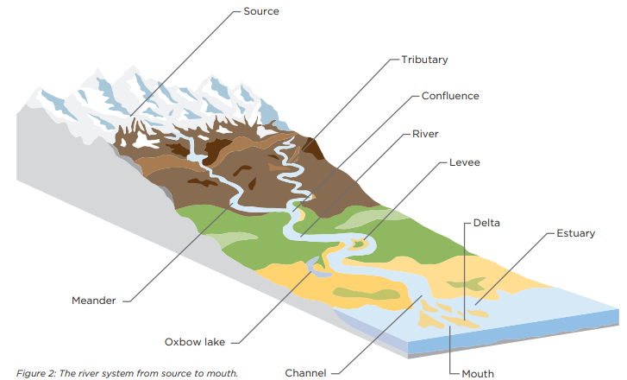
Main local rivers: the Tyne, the Tees, the Derwent, the Wear.  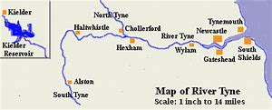  England’s longest river – The Severn (220miles)  River facts around the world:  - The longest river: The Nile (4160 miles)  - The widest river: the Amazon (about 200 miles at the mouth!)  - The river with the most water: the Amazon | Wildlife of the River Tyne:  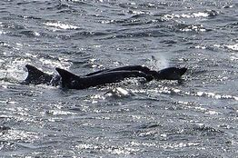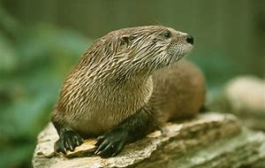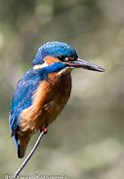  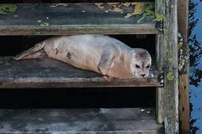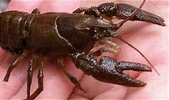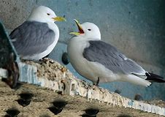

Ge2/1.3a describe and understand key aspects of physical geography, including: rivers and the water cycle.
Ge2/1.3b describe and understand key aspects of human geography, including: types of settlement and land use, the distribution of natural resources including energy, food, minerals and water.
