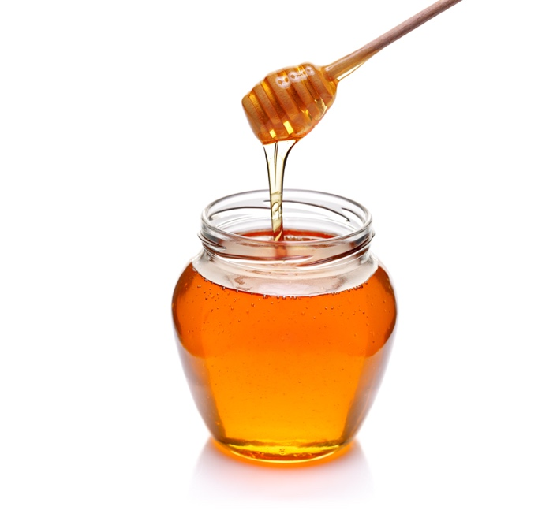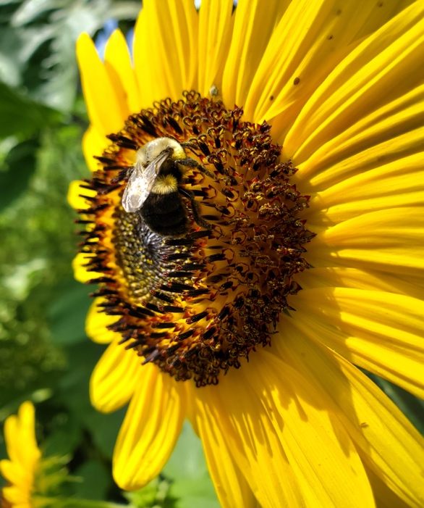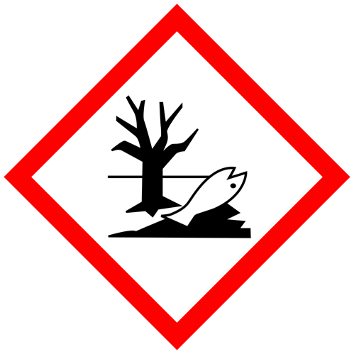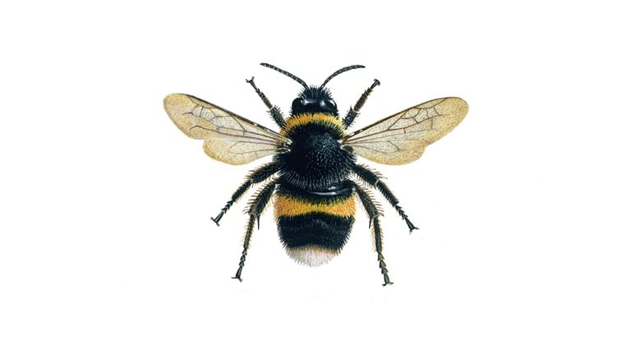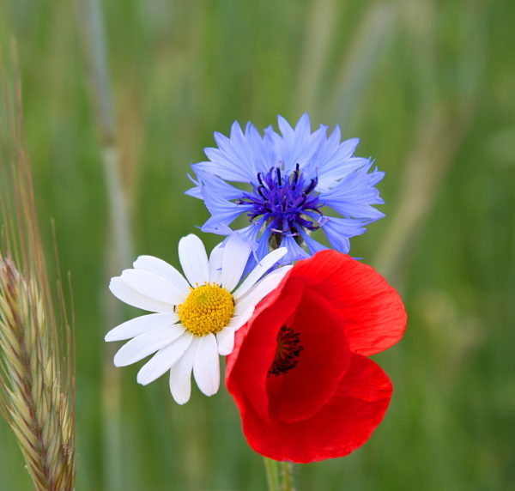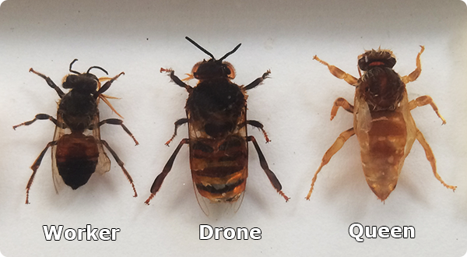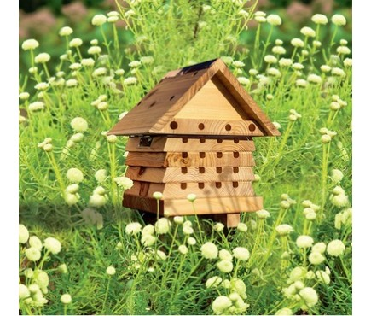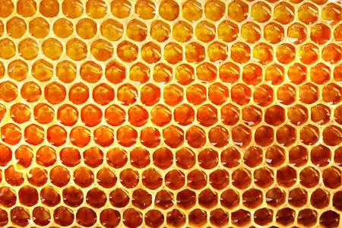3093112

**Flowers** are needed to produce fruit and vegetables. We need to eat fruit and vegetables to keep us healthy. Flowers are seasonal and are most obvious in summer.

Bees **pollinate** flowers when they rub pollen into the middle of a flower. This helps the flower change into a fruit. vegetable or seed.

A **bee** is an insect with wings that typically has yellow and black stripes. It can sting. It makes wax and honey and lives in a large community called a hive.

There are different **types of bee.** There is only one queen in a hive. Worker bees are female and collect pollen and nectar. Drone bees are male bees and help make new bees.

Bees are **endangered.**

Our actions as humans can affect others.

Pesticides are dangerous to bees.

**The world.** Bees prefer to live in warm places in the world. Our world relies on clean air from plants and flowers. The countryside provides lots of flowers for bees but there are not as many in the city.

**Honey** and beeswax is made by bees.

Bees need flowers to make honey.

Honey and beeswax can be used for things like candles or medicine.

Bees live in a **hive**. We all have a home and our families may look different.

**Bee trackers**

m