DRAFT ITINERARY

Day 1: | Monday 22nd May 2017

14:00 hrs | Arrive Newcastle Airport by school minibus
Parents are asked NOT to come to the airport to wave us off!
Children will be given a school lunch but might want to buy drinks/snacks at the airport (approx. £5)

15:50 hrs | Depart Newcastle Airport – Easyjet
19:20 hrs | Arrive at Barcelona El Prat Airport
 | Group will transfer to the hotel by coach. All other journeys whilst in Barcelona will be by public transport.
20:30 hrs | Anticipated arrival at Urbany Hostel – Av.Meridiana,97,08026 Barcelona - where the group will spend the next 2 nights with Bed & Breakfast accommodation.
21:00 hrs | Out for food – Poblenou (15 min walk)  Children will need to pay for an evening meal (approx. €10)
Day 2: |  | Tuesday 23rd May 2017

 | Continental breakfast will be served at the hotel.
10:00 hrs | Parc Guell by metro, self guided group tour
14:00 hrs  18:00 hrs | Metro to Barcelona Beach and picnic lunch (approx. €5-10)  Walk back to hotel – shower and change for dinner  Walk to Poblenou restaurant. Children will need to pay for evening meal (approx. €10)

Day 3: | Wednesday 24th May 2017

 | Continental breakfast will be served at the hotel
10:00 hrs | Metro then bus to Tibidabo  Light lunch in the snack bar (€5-10)
14:00 hrs  18:00 hrs | Bus back to Catalunya (main square). Afternoon spent in Las Ramblas area and food market  Children will need to pay for early evening meal (approx. €10)  Back to hotel to collect bags, then train to the airport at approx. 19:00
19:45 hrs | Arrive Barcelona El Prat Airport
21:35 | Depart Barcelona Airport
23:20 | Arrive at Newcastle Airport
Parents collect children from Newcastle Airport arrivals at approximately 11:45pm. Please come in to the terminal building and wait at the arrivals gate (next to Greggs). Please do not arrive late!

Keep up with us on facebook and twitter:
https://www.facebook.com/stjohnsprimaryschoolnewcastle
https://twitter.com/StJohnsNE4

In case of emergency, ring the school mobile on 07815968699.

IMPORTANT REMINDER: We are travelling with hand luggage only. Cases must be the following size and no bigger:

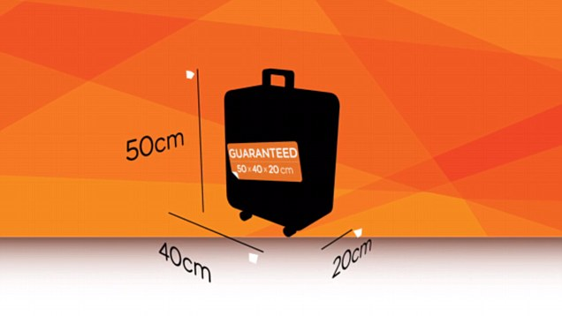

No liquids at all must be carried in the children’s cases. Toothpaste, shampoo, toiletries, suncream etc will be provided at the hotel. No lipgloss, make up etc allowed.

Essential packing list:

Item
Bath towel x1
Beach towel x1 (optional)
Swimwear x1
t-shirts (not vest tops to avoid sunburn – or must pack a cardigan/layer to wear over the top)
Shorts/skirts
Cardigan, jumper, hoody or jacket
Hat/cap
Pyjamas
Comfortable shoes (we’ll do lots of walking so not sandals or flip flops)
Medication identified on care plan form (if any)

