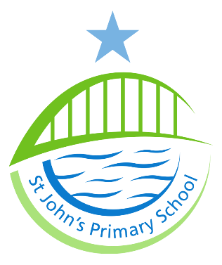

St John’s Primary School

Job Description

Post Title Breakfast Club Assistant/ Bus Escort AA704
Evaluation 311 Points Grade: N2
Responsible to Head Teacher
Responsible for N/A
Job Purpose To assist in the supervision and welfare of children who use the school mini bus pick up service and attend the Breakfast Club in accordance with
school policies/procedures.

Main Duties: The following is typical of the duties the postholder will be
expected to perform. It is not necessarily exhaustive and other
duties of a similar nature and level may be required from time
to time.

1 Assist with the organisation, maintenance, setting out and clearing away of
resources to create a purposeful and attractive learning environment.

2 Assist with any administrative tasks such as attendance registers, collection of
fees etc.

3 Undertake activities with pupils that promote the development of intellectual,
moral, spiritual and social skills.

4 Respond to the practical needs of children where there is an identified special
educational need.

5 Provide general care and welfare by responding appropriately to the social,
emotional and physical needs of pupils.

6 Assist in maintaining a healthy, safe and secure environment and act in
accordance with the School’s policies and procedures.

7 To promote and implement the Council’s Equality Policy in all aspects of
employment and service delivery.

8 The postholder will have responsibility for promoting and safeguarding the
welfare of children and young persons s/he is responsible for, or comes into
contact with.

