**Expressive Arts and Design**

* Weekly music lessons
* Painting jungle animals using a range of different media during art
* 3D model work linked to the jungle
* Explore animal pattern

**Physical Development**

* Weekly PE lessons
* Activities to develop fine manipulative skills
* Healthy eating focus
* Find out about what helps us to be healthy

**Maths**

* Recognise and name 2D and 3D shapes
* Maths Stories
* Use mathematical vocabulary such as add, take away and equals
* Say one more than or one less than a given number
* Record numbers
* Make and continue a pattern
* Sequence numbers
* Compare height and weight of objects

**Understanding the World**

* Find out where you would find jungle animals
* Role-play linked to a small world jungle area
* Look at endangered animals
* Non-fiction books about jungle animals and plants
* Jungle habitat
* ICT, recording jungle stories

**Reception Class Term 2**

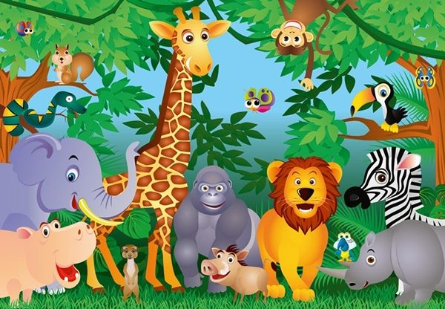

**Jungle Explorers**

**Literacy/Communication and Language**

* Daily RWI lessons
* Talk about and describe a jungle
* Design jungle books
* Write lists of what we would take on an expedition into the jungle
* Reading and writing jungle poems
* Talk for Writing - The Big Carrot
* Sharing books about the jungle

**PSED**

* Circle time and assemblies
* How to care for their environment and jungle animals
* Discuss right and wrong. Should wild animals be kept in a zoo